CASE STUDY ON

AMAZON LIGHTSAIL



**INTRODUCTION**

**Amazon Lightsail** is the easiest way to get started with Amazon Web Services (AWS) for developers who need to build websites or web applications. It includes everything you need to launch your project quickly - instances (virtual private servers), container services, storage buckets, managed databases, SSD-based block storage, static IP addresses, load balancers, content delivery network (CDN) distributions, DNS management of registered domains, and resource snapshots (backups) - for a low, predictable monthly price.

**AWS Lightsail features:**

* **Quick and simple setup:** Setting up AWS Lightsail instance is a fairly simple task as compared to running an ECS or EC2 service.
  + Can be provisioned from AWS console.
  + Can be directly set up from AWS LightSail.
  + Can be managed and set-up from AWS CLI.
* **Cheaper:** AWS Lightsail is cheaper as compared to EC2 and ECS service. Implying that it won’t offer as many features and as much configuration freedom as an EC2 instance.
* **Multiple Instances:** You can run multiple instances of AWS Lightsail and have them communicate with each other to make a fairly complex use case.
* **Connection to other services:** AWS Lightsail can connect to other AWS Resources much like any other EC2 instance.
* **Less configuration:** AWS Lightsail instance can be provisioned from a single page of configurations. It also has some pre-configured settings to support faster deployments. Following are some of the commonly used website configurations provided by AWS Lightsail:
  + WordPress
  + WordPress MultiSite
  + PHP-5 LAMP Server
  + PHP-7 LAMP Server
  + Node.js
  + MEAN
  + Nginx

**HANDS ON**

**Steps 1:** search LightSail in the management console,then click on **lets get started**

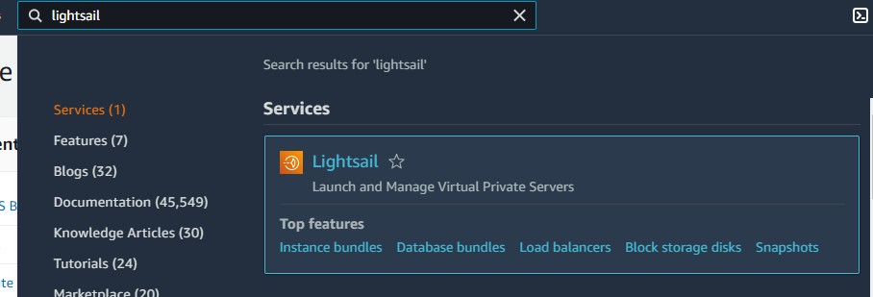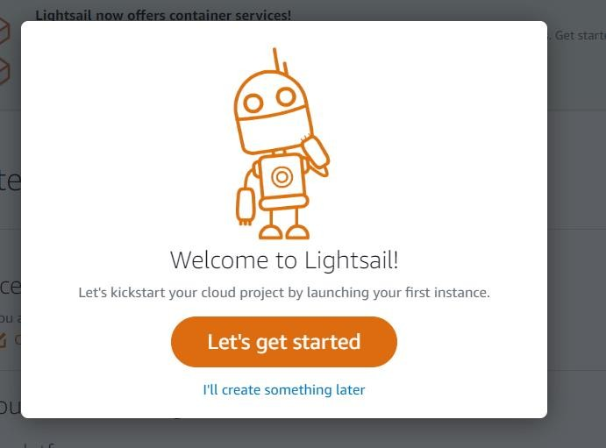

**Steps 2:** Choose the **instance location** and **instance image** as per your requirement.

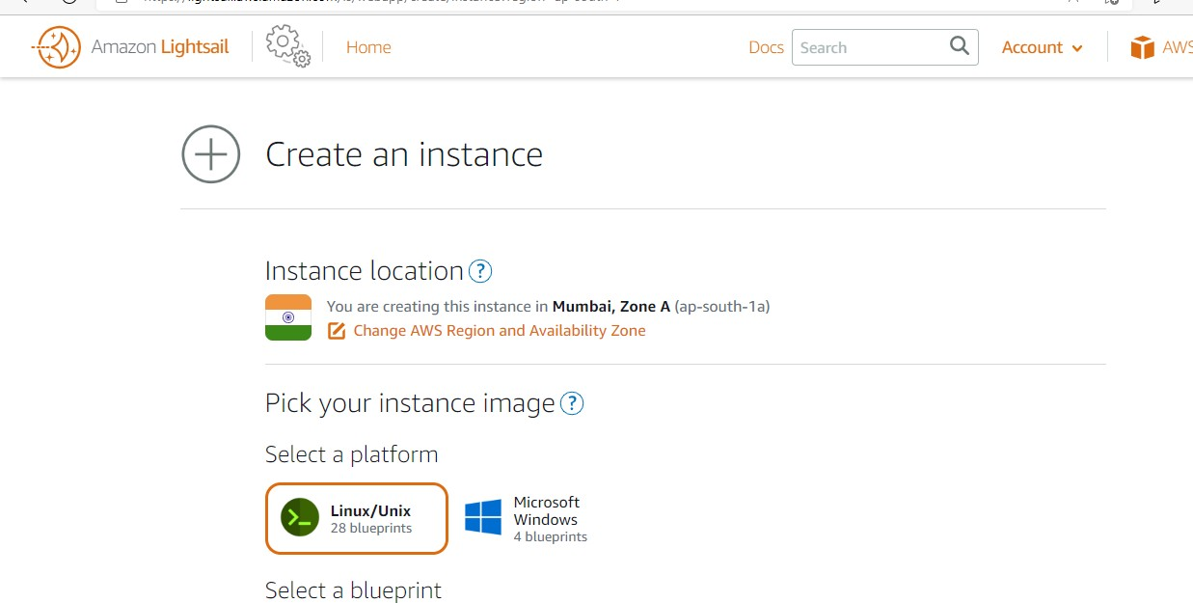

**Steps 3:** Select a blueprint as per your requirement. For the demo purpose I am choosing wordpress.

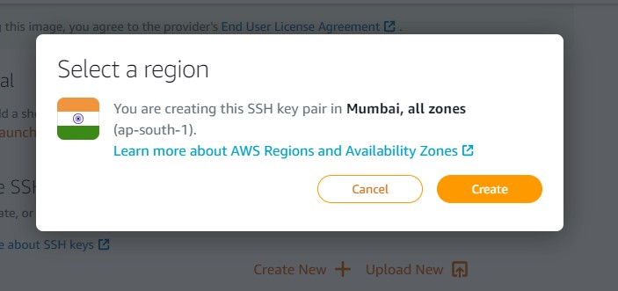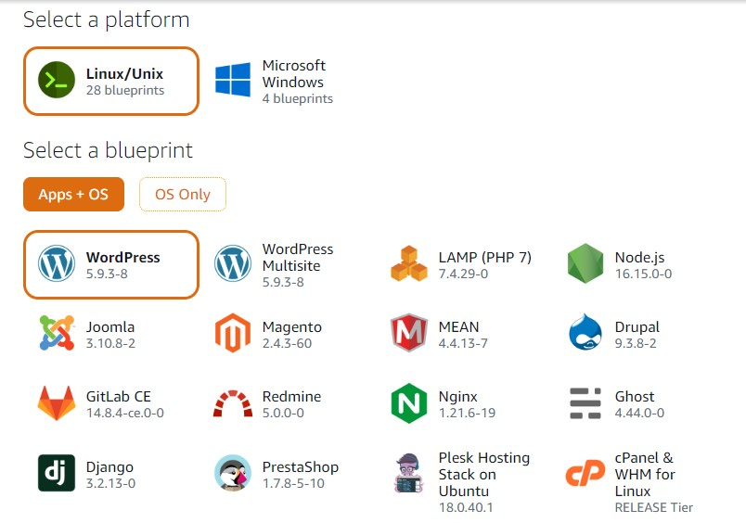

**Steps 4:** Now create a new ssh key pair by clicking on

**create new** then select **create**

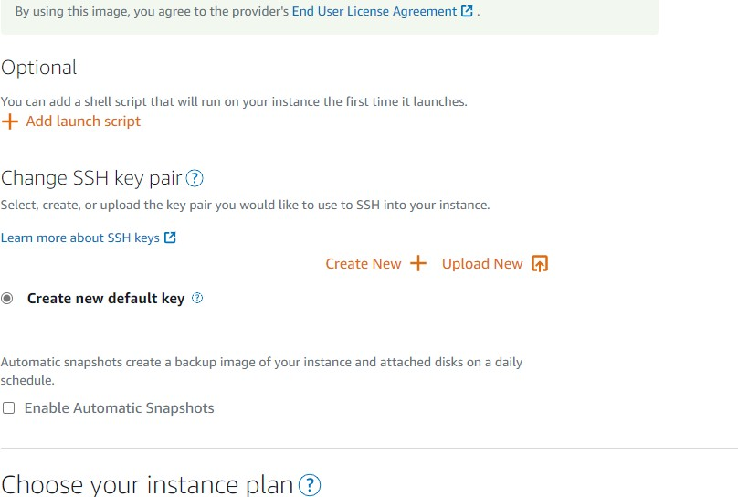

**Steps 5:** Now download the private key as it can be available once only.

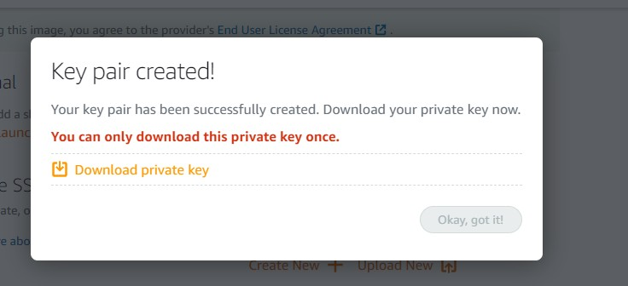

**Steps 6:** You can see lightsail keypair has been created now choose your instance plan.

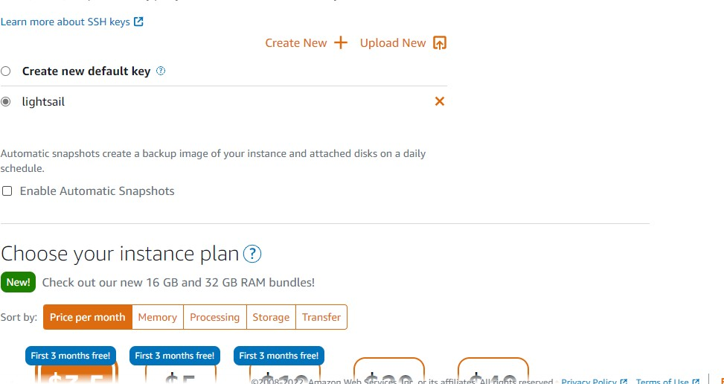

**Steps 7:** Give the name of your instance

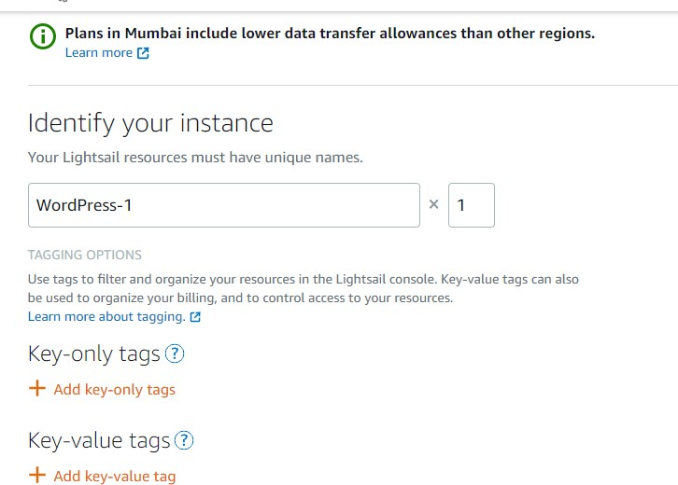

**Steps 8:** Now click on create instance.

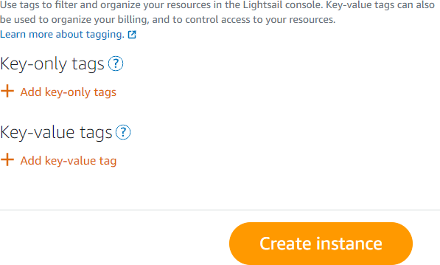

**Steps 9:** Now your instance as been created. To connect to your instance click on 3 dot and click on connect

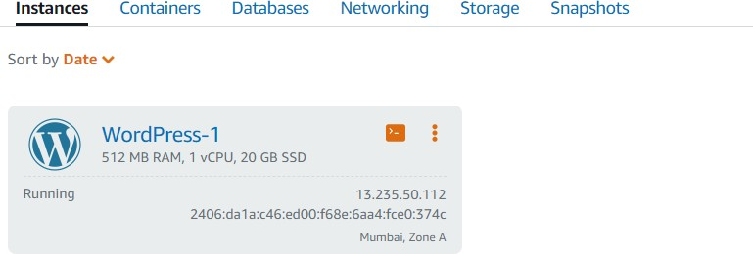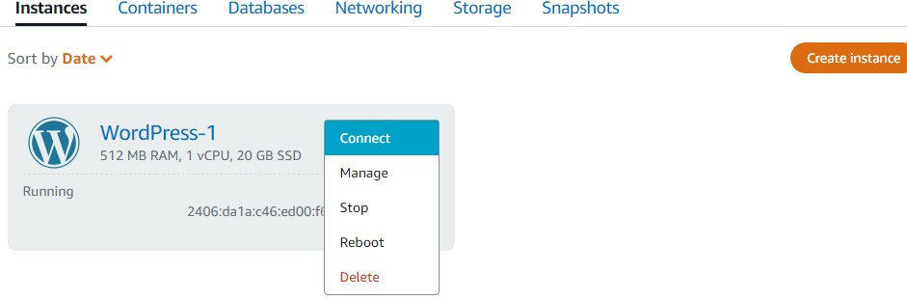

**Steps 10:** Now you can see you have connected to your

machine.

